Designs for UI

**Starting Screen**

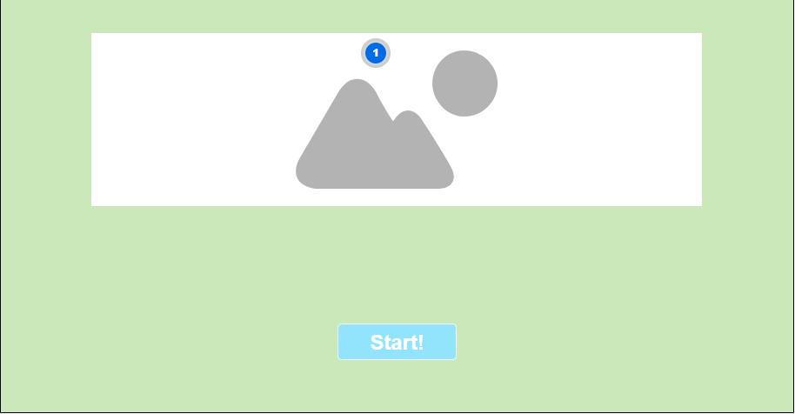

#91e4fb

#cbe8ba

**Choose Game Type**

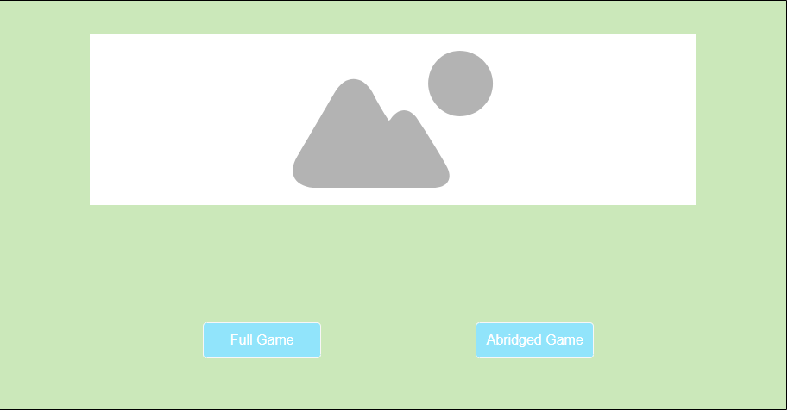

**Choose Players**

#4dd7fa

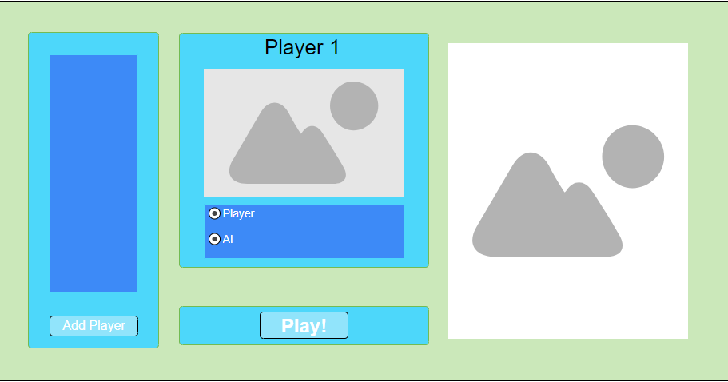

#3d8af7

**Game board**

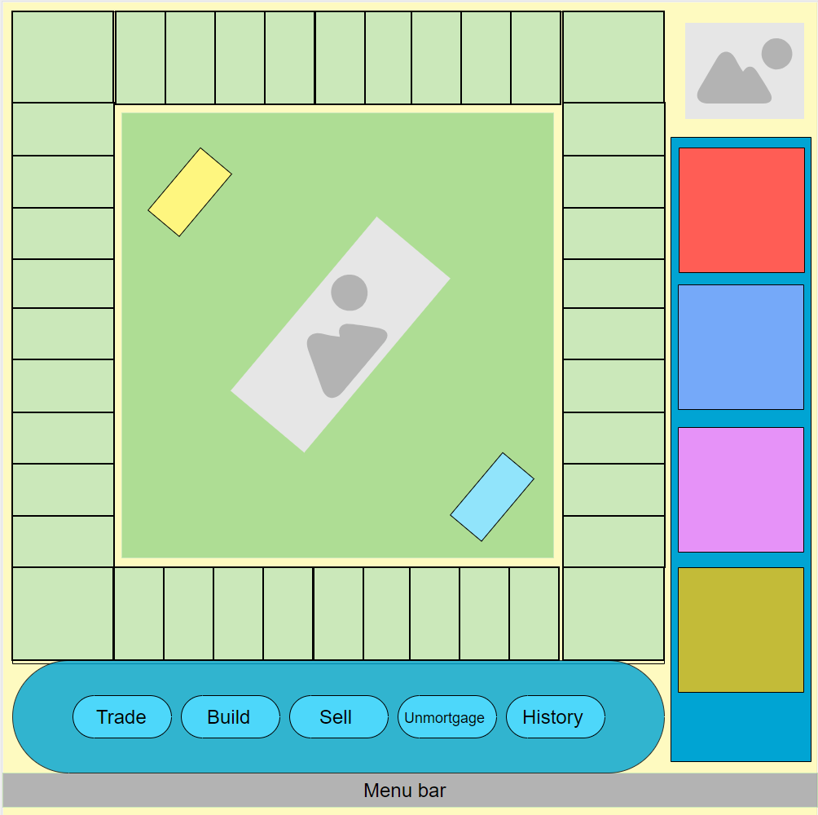

#e692f8

#e692f8

#ff5d55

#ff5d55

#fefac0

#b3b3b3

#4dd7fa

#00a4d3

#aedd94

#aedd94

#cbe8ba

#fef67f

**Purchase Window**

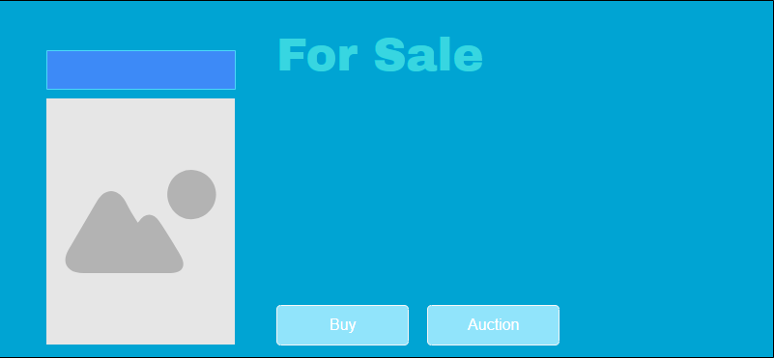

#91e4fb

#37d6e1

#00a4d3

#3d8af7

**Your turn Notification**

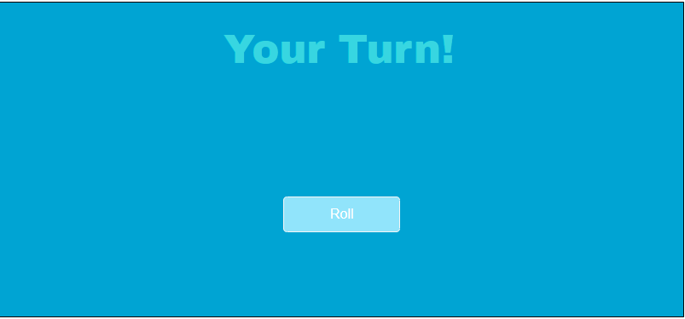

**Chance/Community Card Notification**

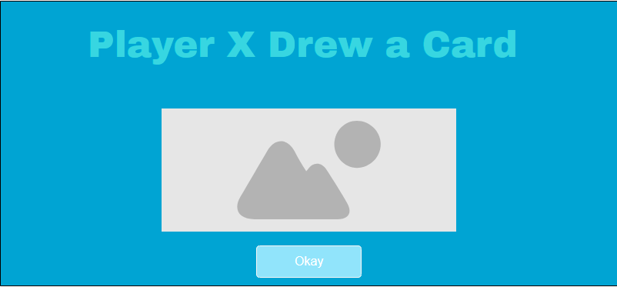

**Start Trade Window**

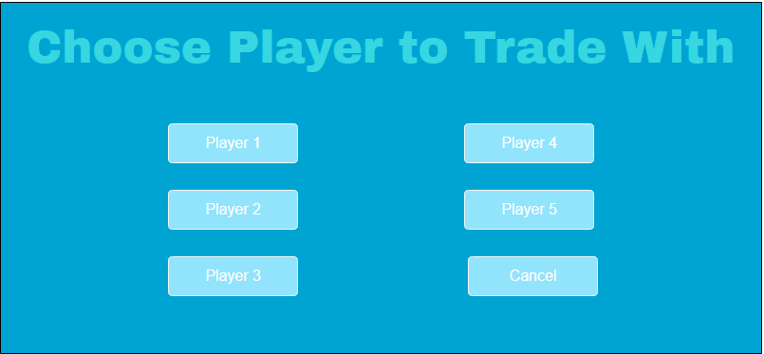

**Trade Request**

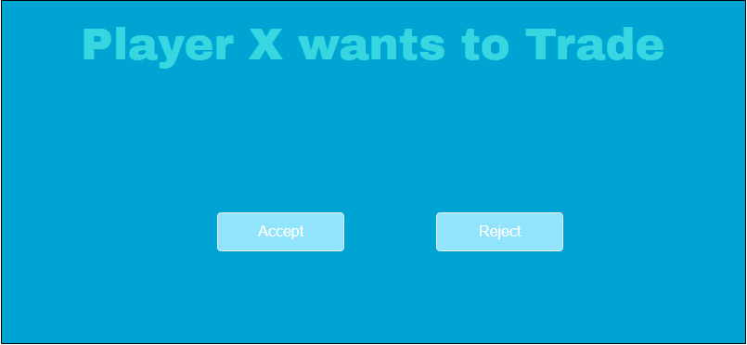

**Player Bankrupt Notification**

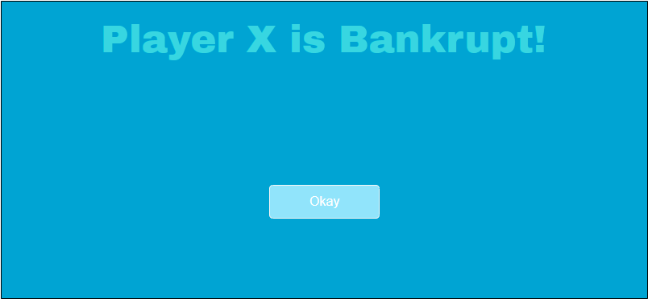

**Bankruptcy window**

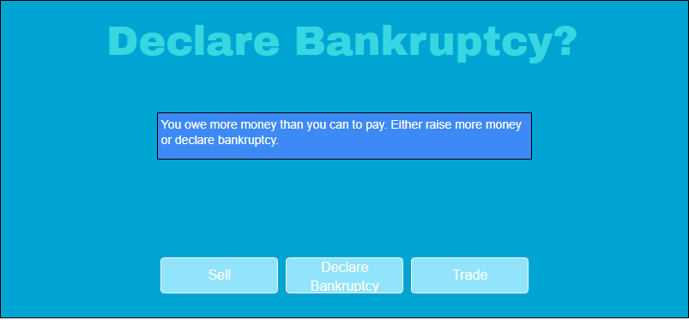

#3d8af7

**Jail Window**

